For managing the Jar dependencies we can create Maven Project. So just give your required jar file name in POM.xml file so it will download all dependencies from Maven Repository.

Which will store in your system> users> username>.m2 folder

Let’s create a project.

File> new> others> maven> maven project

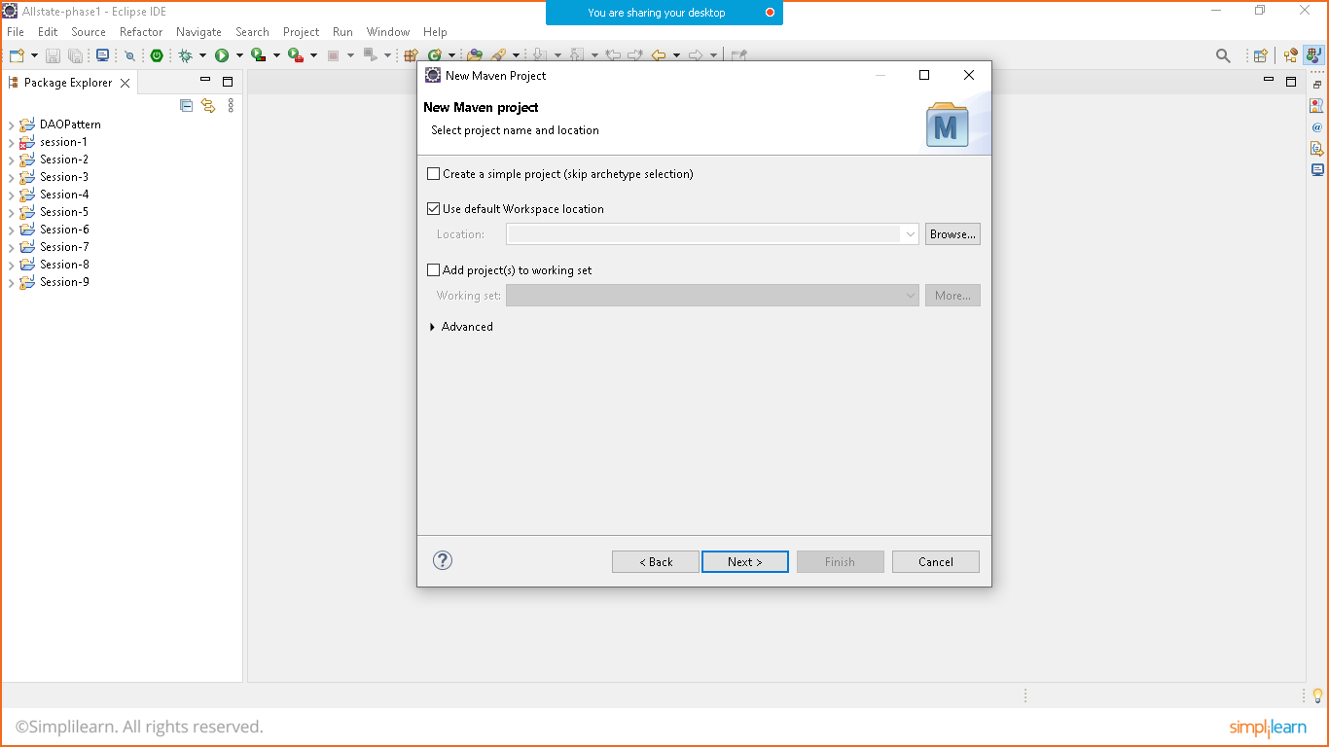

Click on next

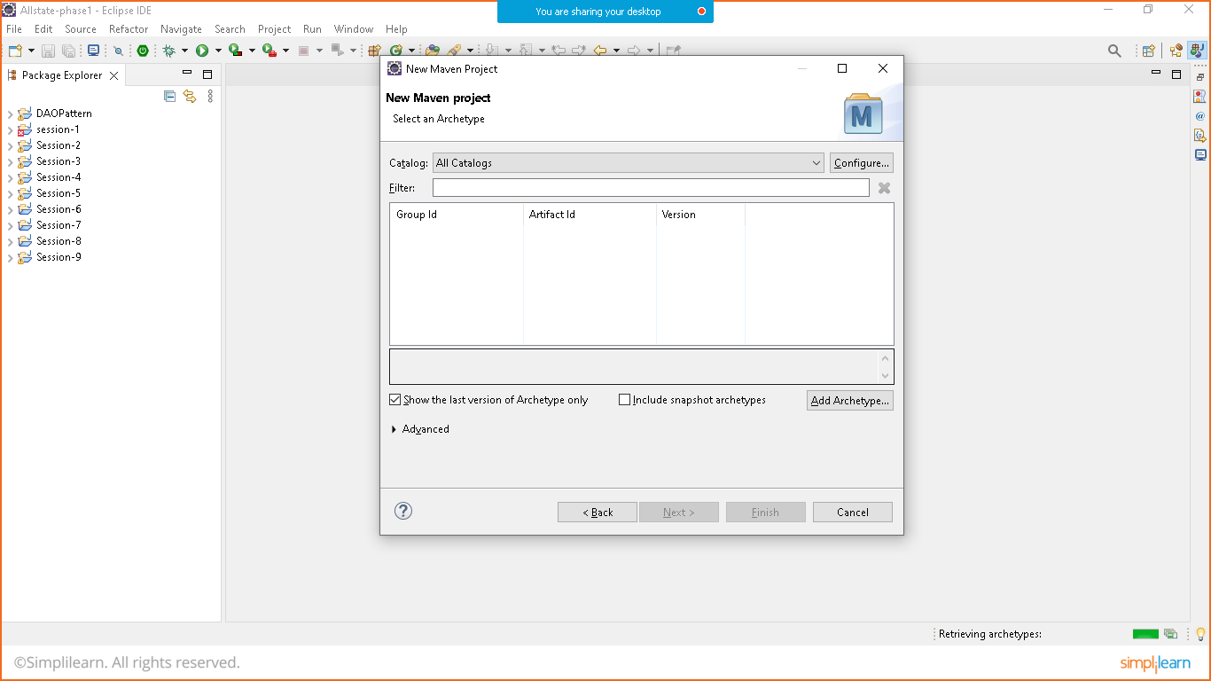

Click on all catalog drop down and select internal

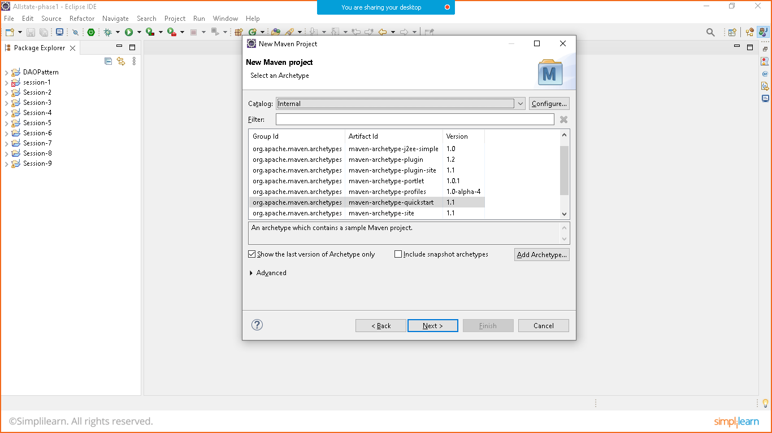

Choose quick start and click on next

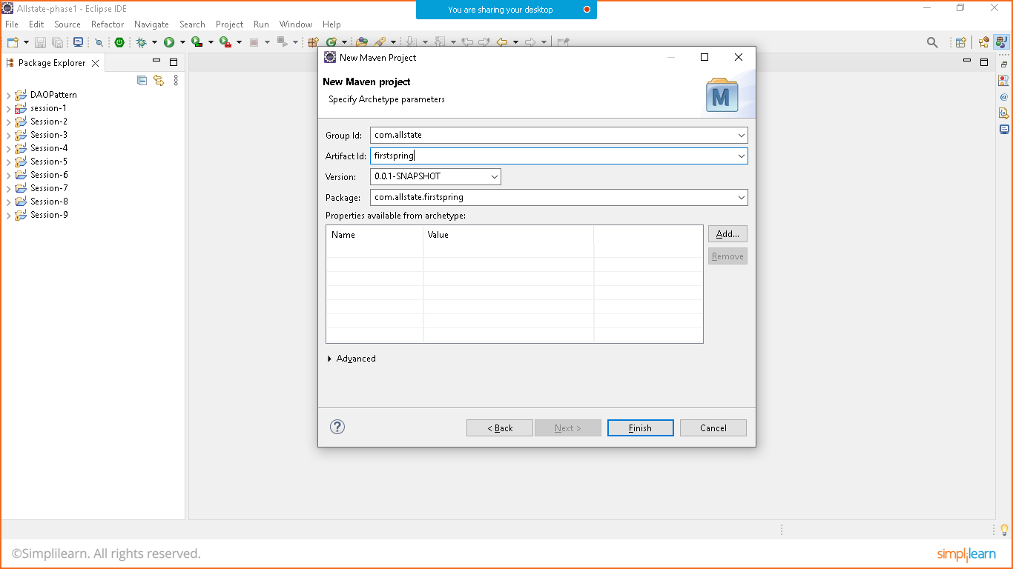

Click on finish.

It will take some time for the first time as it is downloading the quick start template from maven repository.

Open pom.xml file to add dependencies.

Add Spring core, context and beans dependencies in dependencies tag.

<!-- Spring Core -->

<dependency>

<groupId>org.springframework</groupId>

<artifactId>spring-core</artifactId>

<version>5.3.22</version>

</dependency>

<!-- Spring context-->

<dependency>

<groupId>org.springframework</groupId>

<artifactId>spring-context</artifactId>

<version>5.3.22</version>

</dependency>

<!-- Spring Beans -->

<dependency>

<groupId>org.springframework</groupId>

<artifactId>spring-beans</artifactId>

<version>5.3.22</version>

</dependency>

Save so it will download all Required Jar files.

Let’s create A Java class.

**package** com.allstate.firstspring;

**public** **class** Hello {

**public** **void** helloWorld() {

System.***out***.println("Welcome from Hello Class");

}

}

Let’s configure the same by using Spring Framework.

Project>source folder> name (src/main/resources) > Ok

Right click on resources and create new XML file (beans.xml)

In beans file document definition is required which we can define by DTD (document type definition) or By XSD (Schema based definition)

We will go for XSD.

<https://docs.spring.io/spring-framework/docs/4.2.x/spring-framework-reference/html/xsd-configuration.html>

for DTD and XSD details.

<?xml version=*"1.0"* encoding=*"UTF-8"*?>

<beans xmlns=*"http://www.springframework.org/schema/beans"*

xmlns:xsi=*"http://www.w3.org/2001/XMLSchema-instance"*

xsi:schemaLocation=*"*

*http://www.springframework.org/schema/beans http://www.springframework.org/schema/beans/spring-beans.xsd"*>

<!-- h is the object of Hello Class -->

<bean id=*"h"* class=*"com.allstate.firstspring.Hello"*></bean>

</beans>

Let’s Take this Bean in main class

**package** com.allstate.firstspring;

**import** org.springframework.beans.factory.BeanFactory;

**import** org.springframework.beans.factory.xml.~~XmlBeanFactory~~;

**import** org.springframework.core.io.ClassPathResource;

**import** org.springframework.core.io.Resource;

**public** **class** App

{

**public** **static** **void** main( String[] args )

{

Resource resource= **new** ClassPathResource("beans.xml");

BeanFactory factory= **new** ~~XmlBeanFactory~~(resource);

Hello h=(Hello)factory.getBean("h");

h.helloWorld();

}

}

Save all the files. Run the main method and check.